**TUGAS PRAKTEK ALGORITMA PEMROGRAMAN**



Faathir Akbar Nugroho

4522210033

A

Pseudocode (Soal 3)

ALGORITMA

KAMUS/DEKLARASI VARIABEL

Faathir, Akbar[Faathir], Nugroho, Total : int

ALGORITMA/DESKRIPSI

Faathir = 10

Akbar[Faathir] = {1, 4, 9, 16, 25, 36, 49, 64, 81, 100}

for (Nugroho=0; Nugroho<Faathir; Nugroho++)

Total=sqrt(Akbar[Nugroho])

Print(Total)

Endfor

Algoritma/Bahasa alami (Soal 3)

1. Faathir = 10

2. Nugroho = 0

3. Akbar[Faathir] = {1, 4, 9, 16, 25, 36, 49, 64, 81, 100}

4. Selama (Nugroho<Faathir ) kerjakan baris 5 s.d. 7

5. Total 🡨 sqrt(Akbar[Nugroho])

6. Mencetak isi/variabel Total

7. Nugroho++

8. Selesai

Program (Soal 3)

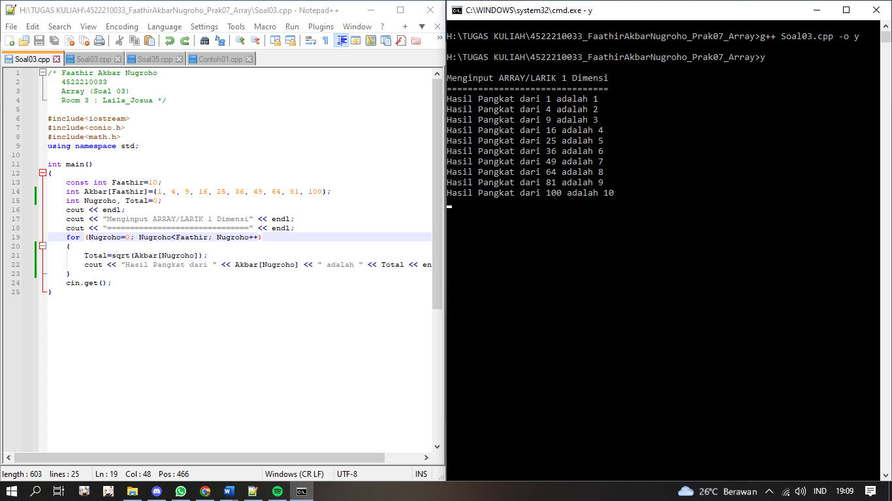

Algoritma/Bahasa alami (Soal 1)

1. Const Akbar = 7

2. Faathir = 0

3. Selama (Faathir < Akbar) kerjakan baris 4 s.d 6, kalau tidak kerjakan baris 7

4. Mencetak isi/variabel (Faathir + 1)

5. Menginput isi/variabel Nugroho[1]

6. Faathir++

7. Selama (Faathir < Akbar) kerjakan baris baris 8 s.d 10, kalau tidak kerjakan baris 11

8. Mencetak isi/variabel (Faathir + 1)

9. Mencetak isi/variabel Nugroho[Faathir]

10. Faathir++

11. Selesai

Program (Soal 1)

